**Insert School Logo**

**Semester One**

**Examination 2022**

**Question/Answer booklet**

**HUMAN BIOLOGY**

**UNIT 1**

SOLUTIONS

**Time allowed for this paper**

Reading time before commencing work: ten minutes

Working time: three hours

**Materials required/recommended for this paper**

***To be provided by the supervisor***

This Question/Answer booklet

Multiple-choice answer sheet

***To be provided by the candidate***

Standard items: pens (blue/black preferred), pencils (including coloured), sharpener, correction fluid/tape, eraser, ruler, highlighters

Special items: up to three calculators, which do not have the capacity to create or store programmes or text, are permitted in this ATAR course examination

***Important notice to candidates***

No other items may be taken into the examination room. It is **your** responsibility to ensure that you do not have any unauthorised material. If you have any unauthorised material with you, hand it to the supervisor **before** reading any further.

**Structure of this paper**

|  |  |  |  |  |  |
| --- | --- | --- | --- | --- | --- |
| Section | Number of questions available | Number of questions to be answered | Suggested working time  (minutes) | Marks available | Percentage of examination |
| Section One  Multiple-choice | 30 | 30 | 40 | 30 | 30 |
| Section Two  Short answer | 8 | 8 | 90 | 107 | 50 |
| Section Three:  Extended Answer | 2 | 1 | 50 | 20 | 10 |
| 2 | 1 | 20 | 10 |
|  |  |  | **Total** | 177 | 100 |

**Instructions to candidates**

1. The rules for the conduct of Western Australian external examinations are detailed in the *Year 12 Information Handbook 2022: Part II Examinations.* Sitting this examination implies that you agree to abide by these rules.
2. Write your answers in this Question/Answer booklet preferably using a blue/black pen. Do not use erasable or gel pens.
3. Answer the questions according to the following instructions.

Section One: Answer all questions on the separate Multiple-choice answer sheet provided. For each question, shade the box to indicate your answer. Use only a blue or black pen to shade the boxes. Do not use erasable or gel pens. If you make a mistake, place a cross through that square, then shade your new answer. Do not erase or use correction fluid/tape. Marks will not be deducted for incorrect answers. No marks will be given if more than one answer is completed for any question.

Section Two: Write your answers in this Question/Answer booklet. Wherever possible, confine your answers to the line spaces provided.

Section Three: Consists of two parts each with two questions. You must answer one question from each part. Tick the box next to the question you are answering. Write your answers in this Question/Answer booklet.

1. You must be careful to confine your responses to the specific questions asked and follow any instructions that are specific to a particular question.
2. Supplementary pages for planning/continuing your answers to questions are provided at the end of this Question/Answer booklet. If you use these pages to continue an answer, indicate at the original answer where the answer is continued, i.e. give the page number.

**Section One: Multiple-choice 30% (30 Marks)**

**Multiple Choice Answers**

|  |  |
| --- | --- |
| **1** | A |
| **2** | C |
| **3** | B |
| **4** | D |
| **5** | C |
| **6** | A |
| **7** | A |
| **8** | B |
| **9** | D |
| **10** | C |
| **11** | A |
| **12** | A |
| **13** | C |
| **14** | D |
| **15** | A |
| **16** | B |
| **17** | D |
| **18** | B |
| **19** | D |
| **20** | B |
| **21** | A |
| **22** | C |
| **23** | A |
| **24** | C |
| **25** | B |
| **26** | B |
| **27** | A |
| **28** | C |
| **29** | B |
| **30** | D |

**Section Two: Short answer 50% (107 Marks)**

This section has **38** questions. Answer **all** questions. Write your answers in the spaces provided.

Supplementary pages for planning/continuing your answers to questions are provided at the end of this Question/Answer booklet. If you use these pages to continue an answer, indicate at the original answer where the answer is continued, i.e. give the page number.

Suggested working time: 90 minutes.

_________________________________________________________________________________

**Question 31 (14 marks)**

1. Aortic valve stenosis, where the valve is unable to fully open, is one of many congenital birth defects and can cause failure to thrive in children. State where this valve is located and explain the effect this condition would have on blood flow through the heart.

(3 marks)

|  |  |
| --- | --- |
| **Description** | **Mark** |
| In between the left ventricle and aorta | 1 |
| Reduces/blocks flow from the heart/left ventricle into your aorta | 1 |
| Increase pressure of the blood in the heart | 1 |
| **Total** | **3** |

1. Lifestyle choices can compromise the functioning of the human body. Describe how a person’s diet can impact their circulatory system.

(3 marks)

|  |  |
| --- | --- |
| **Description** | **Mark** |
| **Any of the following or other appropriate answers:** | |
| Lack of iron | 1-3 |
| Reduces haemoglobin / reduces oxygen transportation |
| Leading to irregular heartbeats / heart failure / enlarged heart |
|  |  |
| Increase in cholesterol / LDL / bad cholesterol / fatty deposits / triglycerides | 1-3 |
| Causing narrowing of arteries / increase blood pressure / clogs arteries |
| Leading to heart attack / stroke / cardiovascular disease |
|  |  |
| Increased alcohol intake | 1-3 |
| Can increase blood pressure / constrict blood vessels |
| Leading to heart failure / cardiovascular disease / heart attack / stroke |
|  |  |
| Increased salt intake | 1-3 |
| Increased blood pressure |
| Heart attack / stroke / cardiovascular disease |
| **Total** | **3** |

Below is a microscopic image showing the lining of a blood vessel.

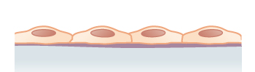

1. Identify the tissue type shown above and briefly describe how its structure allows for effective exchange of gases.

(4 marks)

|  |  |
| --- | --- |
| **Description** | **Mark** |
| Epithelium | 1 |
| One / single layer | 1 |
| Flattened cells | 1 |
| Allowing for short distance of gases to travel | 1 |
| **Total** | **4** |

1. Draw a labelled diagram in the space below to contrast the structural differences between arteries and veins.

(4 marks)

|  |  |
| --- | --- |
| **Description** | **Mark** |
| **Marks awarded for:** | |
| * Correct identification of the artery and vein | 1 |
| * Artery drawn with a thicker wall than the vein - labelled elastic and muscle tissue | 1 |
| * Artery with a narrow lumen, veins with a larger lumen – labelled | 1 |
| * Vein drawn with valves, artery with no valves - labelled | 1 |
| *Example:* |  |
| **Total** | **4** |

**Question 32 (14 marks)**

1. Explain how muscles of the chest area are involved in the process of inspiration.

(4 marks)

|  |  |
| --- | --- |
| **Description** | **Mark** |
| Intercostal muscles contract | 1 |
| Ribs are pulled up and out | 1 |
| Diaphragm muscles contract and move down | 1 |
| Volume of thorax increases and pressure decreases | 1 |
| **Total** | **4** |

Below is a diagram of the respiratory system.

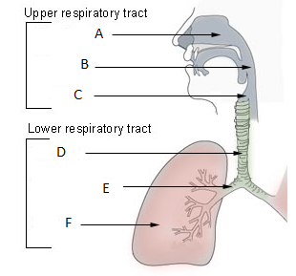

1. Identify the structures located at (2 marks)

|  |  |
| --- | --- |
| **Description** | **Mark** |
| CLarynx | 1 |
| EBronchus | 1 |
| **Total** | **2** |

1. Explain why mucus would be found in the structure identified by the letter D.

(2 marks)

|  |  |
| --- | --- |
| **Description** | **Mark** |
| Trap and remove | 1 |
| Dust / particles / microbes etc. | 1 |
| **Total** | **2** |

1. Differentiate between the types of cartilage found in the epiglottis and the trachea, and state why these types of cartilage are present in these structures.

(6 marks)

|  |  |
| --- | --- |
| **Description** | **Mark** |
| Epiglottis is elastic cartilage | 1 |
| Trachea is hyaline cartilage | 1 |
| Hyaline has more closely packed fibres, elastic has less closely packed fibres | 1 |
| Elastic contains elastic fibres and hyaline contains collagen fibres | 1 |
| Trachea / hyaline - due to the strength and/or flexibility | 1 |
| Epiglottis / elastic – due to flexibility and/or elastic recoil | 1 |
| **Total** | **6** |

**Question 33 (12 marks)**

Floppy baby syndrome is a way of describing a newborn baby with low muscle tone, known as hypotonia.

1. Describe how muscle tone is related to posture.

(3 marks)

|  |  |
| --- | --- |
| **Description** | **Mark** |
| Muscle tone is the partial contraction of skeletal muscles | 1 |
| Muscle tone holds the body parts in position | 1 |
| A person’s posture depends on their muscle tone / muscles holding the body in a certain position | 1 |
| **Total** | **3** |

1. Strengthening of support muscles is a treatment for low muscle tone. When exercising, it is important that resistance is used during both extension and flexion of the arm. Explain the reason for this.

(2 marks)

|  |  |
| --- | --- |
| **Description** | **Mark** |
| Exercises both (antagonistic) pairs of muscles / bicep and triceps muscle | 1 |
| Both of which must work during contraction of the muscles | 1 |
| **Total** | **2** |

Due to the side effects of anabolic steroids, the use of them in Australia is legal only when prescribed by a doctor for proper medical reasons. Athletes sometimes take anabolic steroids illegally to improve their athletic performance. In young people, particularly those whose bones have not yet fully developed, this can speed up the process of cartilage becoming bone.

1. Describe what the term ‘anabolic’ means.

(2 marks)

|  |  |
| --- | --- |
| **Description** | **Mark** |
| Type of reaction in which complex molecules are formed | 1 |
| Requires energy | 1 |
| **Total** | **2** |

1. Outline how consumption of anabolic steroids may impact the bone growth and height of a young person.

(3 marks)

|  |  |
| --- | --- |
| **Description** | **Mark** |
| Bones will harden earlier / bone growth will stop sooner | 1 |
| Resulting in shorter bone length / bones won’t grow as long | 1 |
| Young person not reaching their full potential in height | 1 |
| **Total** | **3** |

1. Another health consequence of anabolic steroids is the stiffening of tendons. What is the function of a tendon and how could this impact the athlete’s performance?

(2 marks)

|  |  |
| --- | --- |
| **Description** | **Mark** |
| Fibrous connective tissue attaching muscle to the bone | 1 |
| Results in injury/decrease in performance | 1 |
| **Total** | **2** |

**Question 34 (11 marks)**

1. Define the term ‘digestion’ and state how it is different to ‘metabolism’.

(2 marks)

|  |  |
| --- | --- |
| **Description** | **Mark** |
| The (chemical and mechanical) breakdown of food into absorbable products | 1 |
| Any **one** difference, such as:   * Only biochemical reactions in metabolism * Break down and build up in metabolism * Digestion occurs externally, whilst metabolism is internal/within cells | 1 |
| **Total** | **2** |

The diagram below illustrates a section of the alimentary canal.

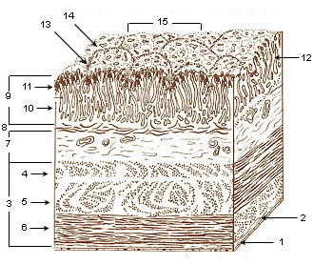

1. Identify the organ to which the section shown in the diagram above belongs.

(1 mark)

|  |  |
| --- | --- |
| **Description** | **Mark** |
| Stomach | 1 |
| **Total** | **1** |

1. Name **one** specific cell that you would find in the epithelial area labelled 9 and give the function of the product it secretes.

(2 marks)

|  |  |
| --- | --- |
| **Description** | **Mark** |
| Any of the following cells with function: | |
| * Mucosal cell / Goblet cell * Secretes mucous for protection | 1-2 |
| * Parietal cell * Secretes hydrochloric acid to aid in the digestion of food/control of bacteria | 1-2 |
| * Chief cell * Secrete pepsinogen which becomes pepsin for breakdown of proteins | 1-2 |
| * G cell * Secrete gastrin which aids the Chief cells/increasing mucosal secretory cells/increase gastric motility | 1-2 |
| **Total** | **2** |

1. Outline how the layers of muscles, identified throughout location 3 in the diagram, aid in the forward movement of the bolus in the digestive system.

(3 marks)

|  |  |
| --- | --- |
| **Description** | **Mark** |
| Circular layer contracts behind bolus to move it forward | 1 |
| Longitudinal layer contracts to shorten alimentary canal | 1 |
| Occurs in a wave-like manner | 1 |
| **Total** | **3** |

Pancreatic cancer patients often show many signs of digestive disturbance, with weight loss and a decrease in appetite quite common.

1. Account for the loss of weight in pancreatic cancer sufferers.

(3 marks)

|  |  |
| --- | --- |
| **Description** | **Mark** |
| Reduction in the number of enzymes reaching the small intestines | 1 |
| Therefore, food is not broken down/absorbed | 1 |
| And the body must use fat/protein stores to create ATP | 1 |
| **Total** | **3** |

**Question 35 (12 marks)**

Excretion applies to the metabolic waste products that cross the cell membrane. The cell membrane is described as a phospholipid bilayer.

1. Describe why phospholipids organise themselves into a bilayer in the presence of water.

(2 marks)

|  |  |
| --- | --- |
| **Description** | **Mark** |
| Protects hydrophobic tails from water | 1 |
| Exposes hydrophilic tails to water | 1 |
| **Total** | **2** |

1. State whether the layers of the plasma membrane bilayer are identical to each other. Give a reason for your answer.

(2 marks)

|  |  |
| --- | --- |
| **Description** | **Mark** |
| No | 1 |
| Due to the presence of proteins/other structures | 1 |
| **Total** | **2** |

1. Why do metabolic wastes need to be excreted from the cells of the body?

(3 marks)

|  |  |
| --- | --- |
| **Description** | **Mark** |
| Wastes can be toxic | 1 |
| Accumulation can lead to cell damage | 1 |
| Resulting in death/prevent cells from functioning properly | 1 |
| **Total** | **3** |

An experiment was undertaken to record the amount of sweat lost over a 60-minute exercise session. The results are shown in the diagram below.

1. Although primarily used for temperature regulation, name **two** metabolic wastes the sweat glands excrete.

(2 marks)

|  |  |
| --- | --- |
| **Description** | **Mark** |
| Any two of the following: | |
| * Water * Lactic acid * Urea * Salts | 1-2 |
| **Total** | **2** |

1. The experiment on sweat rate does not include any controlled variables. Give reason why conclusions from such experiments are undesirable in the scientific community and describe how you would include a control variable.

(3 marks)

|  |  |
| --- | --- |
| **Description** | **Mark** |
| Unsure if the results are due to the variable you want to test | 1 |
| Makes the experiment invalid / decreases validity | 1 |
| One appropriate control variable, such as:   * same exercise undertaken by participants | 1 |
| **Total** | **3** |

**Question 36 (17 marks)**

The diagram below represents the way in which surface area and volume changes with cell size. Each individual, small cube measures 1cm x 1cm x 1cm.

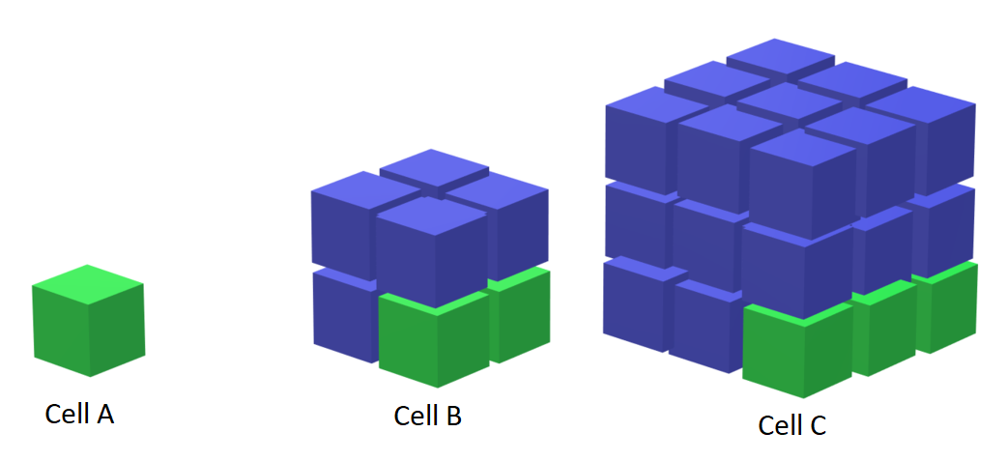

1. Complete the table below by calculating the surface area, volume and surface area to volume ratio for Cell B and Cell C.

(6 marks)

|  |  |  |  |
| --- | --- | --- | --- |
|  | **Cell A** | **Cell B** | **Cell C** |
| **Surface Area** | 6cm2 | 24cm2 | 54cm2 |
| **Volume** | 1cm3 | 8cm3 | 27cm3 |
| **SA:Vol** | 6:1 | 3:1 | 2:1 |

1. State the trend in the surface area to volume ratio seen in the three cells.

(1 mark)

|  |  |
| --- | --- |
| **Description** | **Mark** |
| SA:Vol decreases as cells get bigger | 1 |
| **Total** | **1** |

1. A large surface area to volume ratio is important for the effective functioning of a cell. Identify **two** ways a cell may change their SA:Volume ratio in order to function effectively.

(2 marks)

|  |  |
| --- | --- |
| **Description** | **Mark** |
| Any **two** of the following or other appropriate answers: | |
| * Divide * Change shape * get long and thin (or flat) * develop folds in the cell/cilia | 1-2 |
| **Total** | **2** |

Cells contain thousands of different enzymes that are involved in the many different chemical reactions occurring within them. The rate of these chemical reactions can be affected by a number of factors.

1. On the grid paper below, sketch a simple curve showing the relationship between substrate concentration and the rate of reaction.

(2 marks)

|  |  |
| --- | --- |
| **Description** | **Mark** |
| Rate of reaction on Y axis, substrate concentration labelled on X-axis | 1 |
| Graph increases to a point, where it then rounds off and remains steady | 1 |
| Example answer: | |
| **Total** | **2** |

1. Explain the typical shape of a graph that shows how enzyme activity changes with temperature.

(6 marks)

|  |  |
| --- | --- |
| **Description** | **Mark** |
| Initially enzyme activity increases as temperature increases | 1 |
| Due to increased kinetic energy of molecules | 1 |
| More collisions that have sufficient energy to overcome activation energy | 1 |
| Resulting in more collisions between enzyme and substrate |
| Reaches an optimum temperature | 1 |
| The rate of reaction decreases after optimum | 1 |
| Due to denaturing of the enzyme / change in active site of the enzyme | 1 |
| **Total** | **6** |

**Question 37 (14 marks)**

Bone cells compose less than 2% of the bone mass. The types of cells found within the bone are shown below.

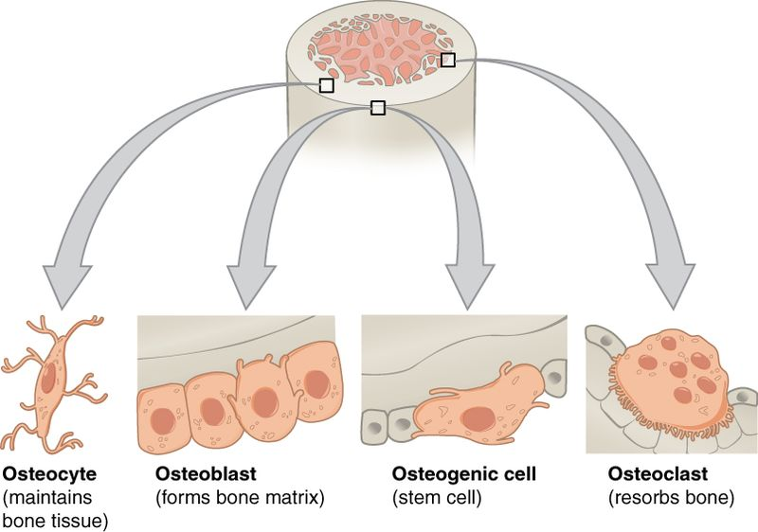

1. What function do osteoblasts serve and where would you find these cells within the bone?

(2 marks)

|  |  |
| --- | --- |
| **Description** | **Mark** |
| Formation of bone matrix / synthesis of new bone cells | 1 |
| Endosteum and/or cell lining of periosteum | 1 |
| **Total** | **2** |

1. Explain how the cellular projections of the osteocyte allow bone cells to communicate.

(3 marks)

|  |  |
| --- | --- |
| **Description** | **Mark** |
| Enter the canaliculi | 1 |
| where they contact other bone cells/osteocytes | 1 |
| allowing materials to be passed between cells | 1 |
| **Total** | **3** |

1. Most bones contain both spongy and compact tissue. Identify **three** differences between these types of tissue.

(3 marks)

|  |  |
| --- | --- |
| **Description** | **Mark** |
| Any three of the following, or other acceptable answers: | |
| * Compact bone is dense, spongy bone is porous | 1-3 |
| * Compact consists of osteons, spongy bone of trabeculae |
| * Compact contains yellow marrow, spongy bone red marrow |
| * Compact bone has no space between lamellae, spongy bone does |
| **Total** | **3** |

The site where two bones connect is known as a joint. The image below shows the sagittal view of an elbow joint.

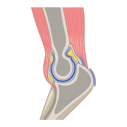

1. Identify the type of synovial joint located at the elbow and state the **two** movements which take place at this type of joint.

(3 marks)

|  |  |
| --- | --- |
| **Description** | **Mark** |
| Hinge | 1 |
| Flexion | 1 |
| Extension | 1 |
| **Total** | **3** |

1. Movement of joints occurs frequently. Describe how the structure of the synovial joint allows for continuous use with minimal damage.

(3 marks)

|  |  |
| --- | --- |
| **Description** | **Mark** |
| Any three of the following: | 1-3 |
| * Fibrous capsule (accept articular capsule) strength resists dislocation |
| * Synovial fluid keeps joint lubricated / prevents bones rubbing on each other/reduces wear and tear |
| * Articulating cartilage provides smooth surface for ease of movement |
| * Bursae prevents friction |
| * Ligament which holds the bones together |
| * Fit of the articulating bones/muscles around joint provide stability |
| **Total** | **3** |

**Question 38 (13 marks)**

A 53-year-old woman began complaining of a dull ache in her left arm and presented with a pale, sweaty face to the first aid station at the Perth Royal Show. The paramedics suspected that she was suffering a myocardial infarction (heart attack), and an ambulance was called. Whilst waiting for the ambulance, the woman was given an oxygen mask and an injection of an isotonic solution into the vein.

1. Explain why the patient was given a supply of oxygen.

(3 marks)

|  |  |
| --- | --- |
| **Description** | **Mark** |
| Heart may not be working / pumping effectively | 1 |
| Meaning the brain is not receiving adequate oxygen | 1 |
| Raise the amount of oxygen reaching the heart and the brain | 1 |
| **Total** | **3** |

1. Explain how the injection of isotonic solution will affect the patient’s extracellular fluid volume. (3 marks)

|  |  |
| --- | --- |
| **Description** | **Mark** |
| Extra Cellular Fluid volume will increase | 1 |
| Isotonic solution will have same concentration as cells | 1 |
| Solution (or water) doesn’t move into the intracellular fluid | 1 |
| **Total** | **3** |

1. Following the 53-year-old patient’s suspected heart attack, her doctor noticed the site of the intravenous injection was red and inflamed. The doctor proceeded to check the size of the patient’s lymph nodes in her armpit. Explain why this was done.

(2 marks)

|  |  |
| --- | --- |
| **Description** | **Mark** |
| Red and inflamed / swollen lymph nodes are suggestive of an infection | 1 |
| due to increase of lymphocytes/WBC being made to fight the disease | 1 |
| **Total** | **2** |

1. Account for the higher percentage of water found in the lungs.

(2 marks)

|  |  |
| --- | --- |
| **Description** | **Mark** |
| Large amounts of mucous that is produced containing water | 1 |
| Gases can only diffuse when dissolved in fluid | 1 |
| **Total** | **2** |

Some of the fluid found within the circulatory system is forced out due to the high pressure of blood entering the capillary beds and is then returned via the lymphatic system.

1. Contrast the lymphatic and circulatory systems.

(3 marks)

|  |  |
| --- | --- |
| **Description** | **Mark** |
| Any **three** of the following, or other appropriate comparisons: | |
| * Lymphatic contains lymph, circulatory system contains blood * Lymphatic system composed of lymph vessels and nodes, circulatory system composed of veins, arteries and capillaries * Lymphatic system flows in one direction/towards the heart, circulatory flows in two directions/towards and away from the heart * Lymphatic system lacks red blood cells, circulatory system contains RBC * Lymphatic fluid moves due to skeletal muscle movement, circulatory fluid moves due to heart contractions * Lymphatic system fluid moves slowly, circulatory system blood moves fast | 1-3 |
| **Total** | **3** |

**Section Three: Extended answer 20% (40 Marks)**

**Part 1**

**Question 39 (20 marks)**

Haemodialysis is a treatment for kidney disease in which external equipment is used to mimic the function of the kidneys. The patient’s blood is passed through artificial membranes within a machine, with dialysis fluid running as a counter-current flow next to the blood.

1. Describe the function of the kidneys and explain why the patient’s blood and dialysis fluid are passed by each other in opposite directions, describing how the waste products are filtered from the blood.

(8 marks)

|  |  |
| --- | --- |
| **Description** | **Mark** |
| **Function of Kidneys:** | |
| Maintain concentrations of substances at optimal levels in body fluids / pH of blood / H+ of blood | 1-2 |
| Excretion of wastes/urea |
| **Counter-current flow:** | |
| Maintains a difference in concentration between blood and dialysis fluid | 1-3 |
| maximising the concentration gradient |
| allowing for faster diffusion |
| **How it filters:** | |
| Works via diffusion | 1-3 |
| Waste concentration in blood is high and in fluid is low |
| Waste moves from areas of high concentration to low concentration |
| **Total** | **8** |

1. Unlike other metabolites, amino acids are unable to be stored in the human body for later use. Outline the steps required in order to remove these excess amino acids, ensuring you refer to the processes occurring within both the liver and kidneys.

(12 marks)

|  |  |
| --- | --- |
| **Description** | **Mark** |
| NH2/Amino group is removed (from amino acid) | 1 |
| In a process called deamination | 1 |
| amino acid + oxygen → carbohydrate + ammonia/NH3 | 1 |
| NH3 + CO2 à urea + H2O | 1 |
| All occur within the liver | 1 |
| Urea travels to the kidney via the blood | 1 |
| Glomerular filtration first occurs where | 1 |
| filtrate containing urea is forced into the glomerular capsule / nephron | 1 |
| Selective reabsorption of some urea occurs across the nephron | 1 |
| Remaining filtrate collects into the renal pelvis / drains into the ureters | 1 |
| Urine is stored in the bladder until excreted | 1 |
| Urine is excreted through the urethra | 1 |
| **Total** | **12** |

**Question 40 (20 marks)**

In nervous tissue, vesicular transport is important for both the release and reuptake of neurotransmitters, which carry information between nerve cells and body parts.

1. Define vesicular transport and describe the different types of vesicular transport that may occur. Include an example of a substance that is transported by each of the different types of vesicular transport.

(12 marks)

|  |  |
| --- | --- |
| **Description** | **Mark** |
| Movement of substances across the cell membrane in membranous sacs / vesicles | 1 |
| Both require ATP / active processes / require energy | 1 |
| Endocytosis | 1 |
| Substances are taken into the cell | 1 |
| Pinocytosis = liquid/water | 1 |
| Phagocytosis = solid | 1 |
| Vesicle formed is suspended in the cytoplasm | 1 |
| E.g. cholesterol / iron ions / micro-organisms / cell debris / other acceptable answers | 1 |
| Exocytosis | 1 |
| Substances are released to the outside of the cell | 1 |
| Vesicle fuses with the cell membrane | 1 |
| E.g. mucus / enzymes / neurotransmitter release / milk secretion / other acceptable answers | 1 |
| **Total** | **12** |

1. At a neuromuscular junction, the neuron transmits a message to the muscle to begin contractions. Briefly outline the sliding filament theory of muscle fibre contraction.

(8 marks)

|  |  |
| --- | --- |
| **Description** | **Mark** |
| Calcium ion (Ca2+) influx | 1-8 |
| Calcium ion attaches to troponin |
| Displaces tropomyosin and |
| myosin binding site (on actin) is exposed |
| ATP is hydrolysed / broken down allowing |
| Myosin to attach to actin |
| Crossbridge forms |
| Power stroke occurs |
| Actin slides / pulled over myosin |
| Z-lines / I-bands / sarcomere shortens |
| **Total** | **8** |

**Part 2**

**Question 41 (20 marks)**

1. Proteins are large, complex molecules that play a variety of critical roles in the human body. Briefly describe the composition of proteins, and outline how each of a cell’s organelles are associated with proteins.

(12 marks)

|  |  |
| --- | --- |
| **Description** | **Mark** |
| **Composition of proteins:** | |
| Made of amino acids | 1 |
| Connected by peptide bonds | 1 |
| **Cell organelles and proteins:** | |
| Golgi body modifies and packages proteins into vesicles for secretion | 1-10 |
| Lysosomes contain enzymes able to break down proteins |
| Proteins are found suspended in the cytosol / cytoplasm |
| Cell membrane contains proteins/protein channels |
| Nucleus houses DNA which determines what proteins are made |
| Nucleolus plays a role in manufacturing proteins / ribosomal proteins |
| Ribosomes are the site of protein production |
| Endoplasmic reticulum transports/synthesises/folds proteins |
| Mitochondria can use proteins as a source of energy |
| Cytoskeleton is made up of proteins |
| Centromeres/Centrioles are complex proteins involved in cell division |
| **Total** | **12** |

1. Cellular respiration can be undertaken in both the presence and absence of oxygen. Outline the process of respiration which occurs when oxygen **is** present.

(8 marks)

|  |  |
| --- | --- |
| **Description** | **Mark** |
| Aerobic respiration | 1 |
| Breakdown of glucose in the presence of oxygen to carbon dioxide and water /  glucose (C6H12O6) + oxygen (O2) → carbon dioxide (CO2) + water (H2O) | 1 |
| Glycolysis occurs in the cytoplasm | 1 |
| Glucose is split into two pyruvate molecules | 1 |
| Pyruvate enters the mitochondria / next steps occur in the mitochondria | 1 |
| Pyruvate is converted to Acetyl CoA / acetyl coenzyme A | 1 |
| Acetyl CoA enters the Krebs / Citric acid cycle | 1 |
| Final stage is electron transport system / oxidative phosphorylation | 1 |
| 36 molecules of ATP produced | 1 |
| **Total** | **8** |

**Question 42 (20 marks)**

1. Blood is made up of plasma and formed elements, with 45% of blood being composed of cells and fragments of cells. Briefly describe the structure and function of the formed elements within blood.

(12 marks)

|  |  |
| --- | --- |
| **Description** | **Mark** |
| **Erythrocytes** | 1 |
| Biconcave / thinner in the middle than at the edges | 1-3 |
| Have no nucleus |
| contains haemoglobin |
| Allows cells to easily move through blood vessels |
| Small cells |
| Transports oxygen from lungs to the cells of the body | 1 |
| **Leucocytes** | 1 |
| Large cells | 1 |
| Variety of structure based on the type of leucocyte |
| Contains a nucleus |
| Role in protecting the body from infection | 1 |
| **Platelets / Thrombocytes** | 1 |
| Smaller than a red blood cell | 1-2 |
| Fragments of cells |
| No nucleus |
| Role in clotting of the blood | 1 |
| **Total** | **12** |

1. Nutrients, found circulating in the blood, must first be absorbed through the digestive tract. Explain how nutrients are absorbed in the small intestine.

(8 marks)

|  |  |
| --- | --- |
| **Description** | **Mark** |
| Villi absorb nutrients / digested food | 1 |
| Villi are 1mm long | 1-2 |
| Inside is a lacteal (lymph capillary) surrounded by blood capillaries |
| Villi is thin (1 cell thick) |
| The villi move which increases absorption |
| Amino acids absorb via active transport into blood capillaries | 1-5 |
| Fatty acids and glycerol absorbed by simple diffusion into villi |
| Then recombine to form fat absorbed into the lacteal |
| Fat-soluble vitamins are absorbed into the lacteal |
| Water is absorbed into the blood capillaries by osmosis |
| Water-soluble vitamins are absorbed into the blood capillaries by diffusion |
| Simple sugars absorbed via active transport into the blood capillaries |
| **Total** | **8** |

**ACKNOWLEDGEMENTS**

**Question 12** Chaisurivirat, D. (2021). *Types of Charts and Graphs.* Image, adapted and used under license from Shutterstock.com. Retrieved on 27th September 2021, from: <https://www.shutterstock.com/image-vector/types-charts-graphs-1680587845>

**Question 15** Young, K. et al. (2013). *Anatomy and Physiology: Blood Typing (Image).* OpenStax College. Adapted and accessed for free on 5th October 2021, from: <https://openstax.org/books/anatomy-and-physiology/pages/1-introduction>.

**Question 20 & 21** training.seer.cancer.gov, Public domain, via Wikimedia Commons (2006). *Picture of Kidney (Image).* Accessed for free on 13th November 2021, from:

<https://commons.wikimedia.org/wiki/File:Illu_kidney.jpg>

**Question 28** Food & Drug Administration (U.S. Government). (2012). *Nutrition Label.* Image, adapted and used for free from Wikimedia Commons. Accessed 20th October 2021, from: <https://upload.wikimedia.org/wikipedia/commons/1/1e/Nutrition_label.gif>

**Question 30** OpenStax College. (2013). Anatomy and Physiology, Connexions Website. *Types of Cartilage.* Retrieved 18th October, 2021, from: <https://commons.wikimedia.org/wiki/File:412_Types_of_Cartilage-new.jpg>

**Question 31** Jmarchn. (2021). *Simple Squamous Epithelium (Image).* CC BY-SA 3.0 <https://creativecommons.org/licenses/by-sa/3.0>, via Wikimedia Commons. Accessed on 21st October 2021, from: <https://commons.wikimedia.org/wiki/File:Simple_squamous_epithelium.png>

**Question 32** training.seer.cancer.gov, Public domain, via Wikimedia Commons (2006). *Conducting Passages (image).* Accessed for free on 13th November 2021, from: <https://commons.wikimedia.org/wiki/File:Illu_conducting_passages.jpg>

**Question 34** training.seer.cancer.gov, Public domain, via Wikimedia Commons (2006). *Stomach Layers (image).* Accessed for free on 13th November 2021, from: <https://commons.wikimedia.org/wiki/File:Illu_stomach_layers.jpg>

**Question 36** Christinelmiller. (2020). *Unit cell for SA to V ratio with tables.* Image adapted and used CC BY-SA 4.0 <https://creativecommons.org/licenses/by-sa/4.0>, via Wikimedia Commons. Accessed on 30th September 2021, from: <https://commons.wikimedia.org/wiki/File:Unit_cell_for_SA_to_V_ratio_with_tables.png>

**Question 37** OpenStax College. (2013). *Bone Cells (Image).* CC BY 3.0 <https://creativecommons.org/licenses/by/3.0>, via Wikimedia Commons. Accessed on 2nd October 2021, from: <https://commons.wikimedia.org/wiki/File:604_Bone_cells.jpg>

DataBase Center for Life Science (DBCLS). (2021). *Sagittal section through elbow joint (Image).* CC BY 4.0 <https://creativecommons.org/licenses/by/4.0>, via Wikimedia Commons. Accessed on 8th September 2021, from: <https://commons.wikimedia.org/wiki/File:202107_Sagittal_section_through_the_elbow_joint.svg>

**Question 38** Anatomy & Physiology. (2013). *Water Content of the Body’s Organs and Tissues (Image).* Provided by OpenStax College, CC BY 3.0. Accessed and downloaded for free on 2nd October 2021, from: https://commons.wikimedia.org/wiki/File:2701_Water_Content_in_the_Body-01.jpg